VisualizationInterpretation and Explanation
The graph below is the customer cluster after applying PCA to reduce it to 2 dimensions.
Each point represents a customer.
Each color corresponds to one cluster, which resulted from K-Means.
The red “X” marks represent the centroids of each cluster.
To facilitate interpretation, cluster labels (Cluster 0, Cluster 1, Cluster 2) have been interpretation.

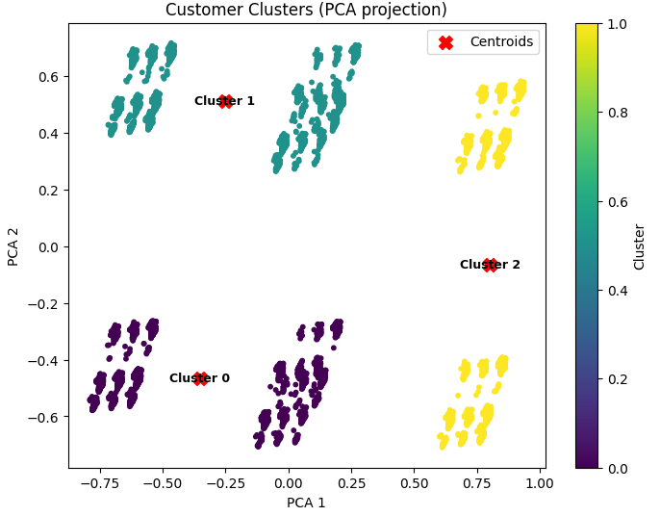

Interpretation of Clusters
Cluster 0 (purple, bottom-left): Customers who share same behavior and characteristics. These could be long-term low-churn customers, or based on the features, potential lower monthly charges.
Cluster 1 (teal, upper-left): Another cluster of customers, perhaps with a middle-medium tenure or different distribution of services.
Cluster 2 (Yellow on right): Another possible segment, depending on your dataset attributes, could be new customers, higher monthly charges, wildly high-risk churners, etc.
Insights Derived from Analysis
There are different sections in the customer base; not every customer behaves similarly.
Specific strategies can be formulated: for instance, retention efforts to the cluster with the higher churn rate, upsell opportunities to the cluster of monthly high spending users and so on.
Clusters are represented by “profiles” of an average customer in each segment. Considering the feature values of the centroid, we may summarize what distinguishes each cluster.
Conclusion
This visualization simply validates that the K-Means model was able to segment the customers into some groups, which seem to make sense. By identifying and labeling the clusters and understanding their profiles, the business can engineer data-driven retention strategies along with customized offers to minimise churn and improve customer satisfaction.

